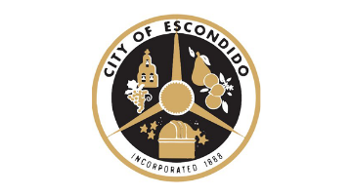
NOTICE OF UNSCHEDULED VACANCY
NOTICE IS HEREBY GIVEN, pursuant to California Government Code § 54974 that an unscheduled vacancy exists on the following:
Public Art Commission
The Public Art Commission functions in an advisory capacity in matters pertaining to art in public places. Areas of focus include:
- Reviewing, selecting, and approving proposed artwork
- Devising methods of selecting and commissioning artists with respect to the design, execution, and placement of art
- Advising the City in matters pertaining to the quality, quantity, scope, and style of art
- Advising the City on the amount of public art funds to be expended on specific art projects
- Reviewing and maintaining an inventory of art and advising in matters pertaining to the maintenance, placement, alteration, sale, transfer, ownership, and acceptance or refusal of donations
- Recommending consultants, seeking grants, donations, gifts, and other funding methods for art and educating the public about art
Meetings are held bi-monthly at 4:30 pm in Council Chambers, 201 N. Broadway, Escondido, CA 92025
Applicants must reside within the geographic boundaries of the General Plan. The term of this seat is set to expire on March 31, 2026. Applications are available at the City Clerk’s Office, City Hall, 201 N. Broadway, Escondido, CA 92025 or by calling (760) 839-4617, or on the City’s website:
https://www.escondido.gov/FormCenter/City-Clerks-Office-6/BOARD-AND-COMMISSION-APPLICATION-130
Application Period Open Until Filled
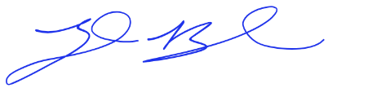
I, Zack Beck, City Clerk of the City of Escondido, do hereby certify that I caused to be posted the foregoing Notice on February 2, 2026, pursuant to the requirements of the California Government Code.

_________________________
Zack Beck, City Clerk

